### **Analysis Models for Forecasting** :(<https://www.youtube.com/watch?v=KdU9xBqsFWc>)

* Descriptive Analysis- Analysis based only on previous data
* Diagnostic Analysis- including the reason along with the data
* Predictive Analysis -Including the AI , Ml to accurately predict the reason for an particular outcome
* Prescriptive Analysis - finding out the best possible decision based on the risks involved with them.

(what we need is an AI system which combines all these)

### Forecasting models:(<https://blog.hubspot.com/sales/sales-forecasting>)

### **1. Opportunity Stage Forecasting**:

Let's say you've established the following likely-to-close percentages based on your pipeline:

* Initial Call: 5%
* Qualified:10%
* Product Demo: 35%
* Product Trial: 60%
* Final Call: 80%
* Deal Closed: 100%

According to this forecasting model, a $1,000 deal at the Product Demo stage is 35% likely to close. The forecasted amount for this deal would be $350.

### 

### 

### 

### **2. Length of Sales Cycle Forecasting**

Let's say your average sales cycle lasts six months. If your salesperson has been working an account for three months, your forecast might suggest they're 50% likely to win the deal

### **3. Intuitive Forecasting**

Let's say you want to forecast sales for your brand new business. You've only been operating for three months and have no historical data. You have two salespeople on your team, so you ask them to forecast sales for the next six months based on their intuition.

Each salesperson examines the deals in their sales pipeline as well as any prospecting opportunities they have planned for the following months. Based on their analysis, they forecast $50,000 in sales for the following six months

### **4. Historical Forecasting**

Let's say your team collectively sold $80,000 in monthly recurring revenue (MRR) in October. Based on this method, you'd assume they'd sell $80,000 or more in November.

You can make this prediction more sophisticated by adding your historical growth. If you consistently increase sales by 6-8% each month, a conservative estimate for November would be $84,800.

### **5. Multivariable Analysis Forecasting**

Imagine you have two reps, each of which is working a single account. Your first rep has a meeting with Procurement scheduled for Friday, while your second rep just gave her first presentation to the buying committee.

Based on your first rep's win rate for this stage of the sales process, combined with the relatively large predicted deal size and the number of days left in the quarter, he's 40% likely to close in this period. That gives you a forecast of $9,600.

Your second rep is earlier in the sales process, but the deal is smaller and she has a high close rate. She's also 40% likely to close, giving you a forecast of $6,800.

Combine those, and you'd get a quarterly sales forecast of $16,400

### **6. Pipeline Forecasting**

If your sales team typically closes deals worth between $5,000 and $8,000 within 60 days, all current deals in your team's pipeline would be given a high likelihood of closing.

You can then use this data to figure your monthly or quarterly forecast.

### **Choosing a sales forecasting method.**

Once you have your sales process, sales quota, and CRM in place, you can choose a [sales forecasting method](https://blog.hubspot.com/sales/sales-forecasting#sales-forecasting-methods).

The method you choose will depend on a few factors, including the age of your business, the size of your sales team and pipelines, and the quality of your sales data and data tracking habits.

If your business is new or doesn't have much historical sales data, the best method for you would be [intuitive forecasting](https://blog.hubspot.com/sales/sales-forecasting#intuitive-forecasting).

If you're just getting started with sales forecasting and have busy sales pipelines, [opportunity stage forecasting](https://blog.hubspot.com/sales/sales-forecasting#opportunity-stage-forecasting), [length of sales cycle forecasting.](https://blog.hubspot.com/sales/sales-forecasting#length-of-sales-cycle-forecasting) These methods both present objective forecasting calculations, however, so if you're looking for more detailed pipeline-specific forecasting, [multivariable analysis forecasting](https://blog.hubspot.com/sales/sales-forecasting#multivariable-analysis-forecasting) and [pipeline forecasting](https://blog.hubspot.com/sales/sales-forecasting#pipeline-forecasting) may be feasible options.

These two work best if your team has impeccable sales data and is in the habit of keeping up with their pipeline data. Lastly, for the most consistent markets and industries, [historical forecasting](https://blog.hubspot.com/sales/sales-forecasting#historical-forecasting) can be a good forecasting model.

Take a close look at your business model, sales team, data tracking, and broader industry before moving forward with a sales forecasting model

**Variable to be given as input for AI model forecasting :**

* Data from user search history ( things searched, time spend on each item,no of websites visited ,relevant search history)
* Season(Divided in quarters)
* Festival Period
* Economic Conditions( Current Industry Manufacturing Potential, R&D costs, Scope of Growth,Economic Indicators(eg: CPI))
* Customer Relations
* Dependent Industries Growing Rate( if mobiles are sold hugely then mobile cover sales are also likely to grow)
* Competitors market condition( Suppose Oneplus in released only on amazon so the sales of realme on flipkart are likely to reduce or if amazon is giving iphone 8 at 44k and Flipkart at 77kk then flipkart should reduce the inventory of iphone 8)

Eg: <https://www.amazon.in/Apple-iPhone-8-Gold-256GB/dp/B071P3764Z/ref=sr_1_17?dchild=1&keywords=iphone+6&qid=1616917927&sr=8-17>

[https://www.flipkart.com/apple-iphone-8-plus-silver-256-gb/p/itmexrgvxatuyrqw?pid=MOBEXRGVGETABXWZ&lid=LSTMOBEXRGVGETABXWZJ0ZD9D&marketplace=FLIPKART&sattr[]=color&sattr[]=storage&st=storage](https://www.flipkart.com/apple-iphone-8-plus-silver-256-gb/p/itmexrgvxatuyrqw?pid=MOBEXRGVGETABXWZ&lid=LSTMOBEXRGVGETABXWZJ0ZD9D&marketplace=FLIPKART&sattr%5B%5D=color&sattr%5B%5D=storage&st=storage)

* Social Media Signals ( Eg : Tweets that cause spike in demands)
* State wise rules & regulations & ease of business doing.

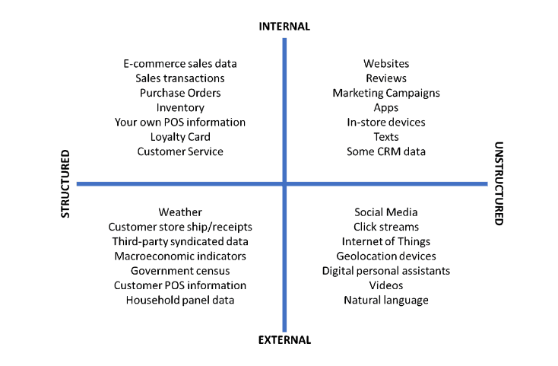

**Problems with traditional Statistical Methods:** (<https://www.altexsoft.com/blog/demand-forecasting-methods-using-machine-learning/>)

* It requires at **least two years of sales data** to give acceptable demand forecasting for that specific product.
* It can forecast sales predictions for mid term to long term planning.
* It is more likely to give results to products with stable demand.(Eg: Model would fail to predict the demand of sanitizers)
* It predicts total demand rather than sales of separate stock-keeping units (SKUs).

**Advantages of using AI enabled demand forecasting:**

* Companies that added machine learning to their existing systems report an increase of [5 to 15 percent](https://www.toolsgroup.com/blog/improving-demand-forecasting-and-planning-with-machine-learning/) in forecast reliability (up to 85 and even 95 percent).
* It enables us to do short term planning.
* It can handle volatile demand and can adjust to fast changing environment.
* It also enable us to forecast the demand of new product launches.

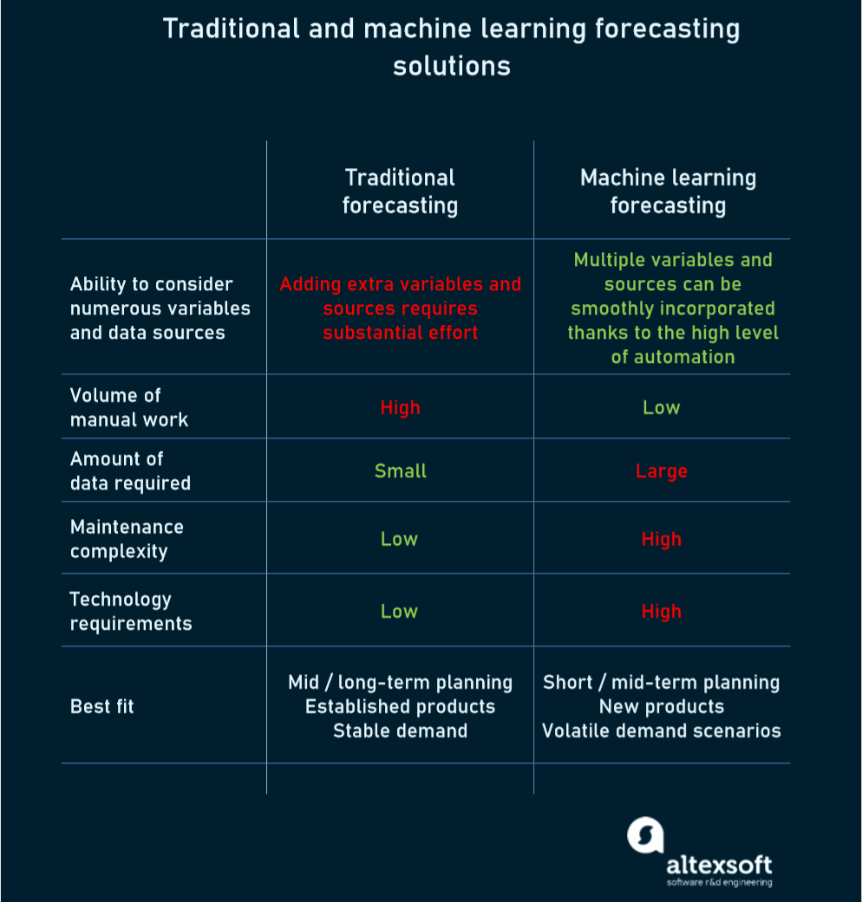

Internal Factors(Structured Data):

* Data from user search history

Things Searched- Categorical Data

Time Spend - Number Easily Available

No of websites, search history- Available from cookies

Credit Scores/Points Of Customers

* Season(Divided in quarters),Festival Period- Categorical Data Available from prev company transaction
* Customer Relation - Available from reviews and return ratio
* Dependent Industries Growing Rate( if mobiles are sold hugely then mobile cover sales are also likely to grow) - Data can be obtained from history of transactions

External Factors(Structured Data):

* Economic Conditions
  + Current Industry Manufacturing Potential- Industry P/E ratio, Relative Beta
  + R&D costs - Numerical Data Directly available from balance sheet of companies
  + Scope of Growth- Piotroski F-Score method directly predicts growth scope
  + Economic Indicators(eg: CPI))- CPI & Inflation rate is directly available from balance sheets.
* Dependent Industries Growing Rate( if mobiles are sold hugely then mobile cover sales are also likely to grow) - Categories can be grouped & no. of sales of the sales of objects within a category can be taken as input.
* Competitors market condition - Price of an object from diff websites can be obtained & if price diff is significantly diff this can be given as input as simple YES or NO.

External Factors(Unstructured Data):

* Social Media Signals
  + Tweets that cause spike in demands - Obtained from tweet activity and no of tags divided into positive & negative tweets.
  + No of Brand Ambassadors used an customer reach of those products that helped ,can be scaled from no of followers
  + No of ads clicked and then directed to user history data part

**Benefits & Advantages of Descriptive Analysis :**

* Compares diff possibilities & gives risk associated with diff decision
* Gives out an optimal soln taking much more factors than any other model
* Uses advanced statistical techniques than any other model
* It can be used in an pipeline with Descriptive & Predictive Analysis
* Extremely Dynamic & adapts effectively with any severe change